**second assignment of c programing .**

**Student Name : محمد ابراهيم محمد السعيد ابراهيم**

**Id : 18011342**

**Section or lab : 8**

**Electrical communication engineering.**

**Code1:-**

#include <stdio.h>

#include <stdlib.h>

int main()

{

int x , y ;

printf("Hi this program is designed to know which quarter that any point lies \n");

printf ("now lets start\n");

printf("now we need you to enter the coordinates of any point \n");

printf("please enter the first coordinate value x\n");

scanf("%d",&x);

printf("please enter the second coordinate value y\n");

scanf("%d",&y);

if (x>0){

if (y>0){

printf(" the (%d,%d) point lies in the 1st quarter.. \n",x,y);

}

else if (y<0){

printf(" the (%d,%d) point lies in the 4th quarter.. \n",x,y);

}

else if (y==0){

printf(" the (%d,%d) point lies in the middle between the 1st quarter and 4th quarter.. \n",x,y);

printf("on the +ve x axis\n");

}

}

else if (x<0){

if (y>0){

printf(" the (%d,%d) point lies in the 2nd quarter.. \n",x,y);

}

else if (y<0){

printf(" the (%d,%d) point lies in the 3rd quarter.. \n",x,y);

}

else if (y==0){

printf(" the (%d,%d) point lies in the middle between the 2nd quarter and 3rd quarter.. \n",x,y);

printf("on the -ve x axis\n");

}

}

else if (x==0){

if (y==0){

printf(" the (%d,%d) point lies in the center.. \n",x,y);

}

else if (y<0){

printf(" the (%d,%d) point lies in the middle between the 3rd quarter and 4th quarter.. \n",x,y);

printf("in the -ve y axis\n");

}

else if (y>0){

printf(" the (%d,%d) point lies in the middle between the 2nd quarter and 1st quarter.. \n",x,y);

printf("in the +ve y axis\n");

}

}

return 0;

}

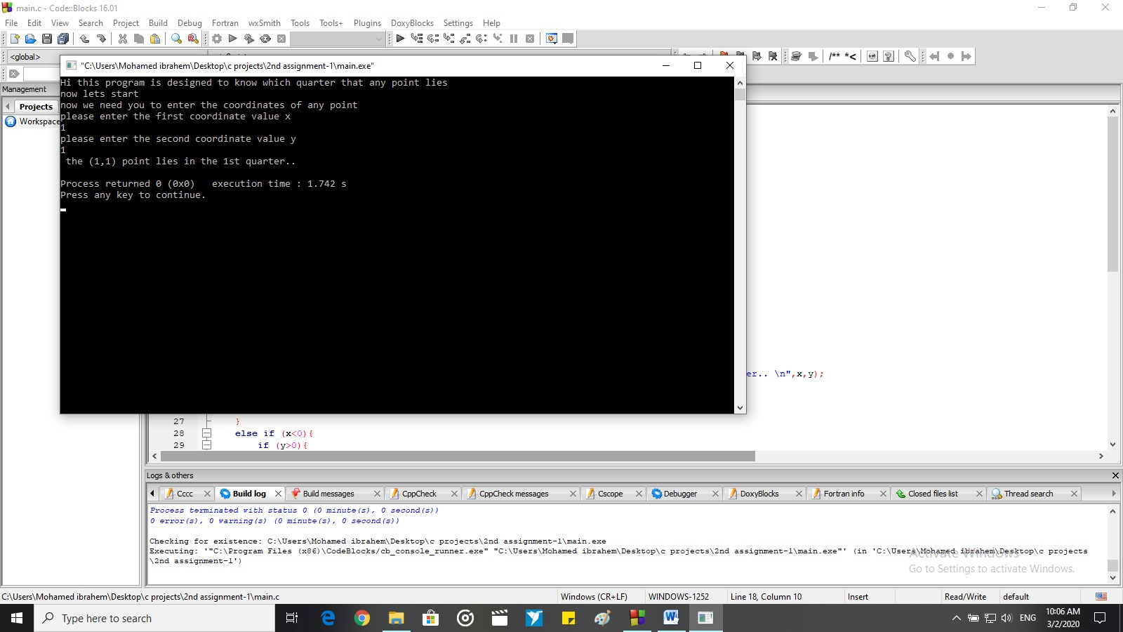

***Code 2***

#include <stdio.h>

#include <stdlib.h>

int main()

{

int year ;

printf("please enter the year number to know if it is a leap year or not\n");

scanf("%d",&year);

if (year%4==0){

if (year%400==0){

printf("year %d is a leap year\n",year);

}

else if (year%100==0){

printf("year %d is not a leap year\n",year);

}

else {

printf("year %d is a leap year\n",year);;

}

}

else {

printf("year %d is not a leap year\n",year);

}

return 0;

}

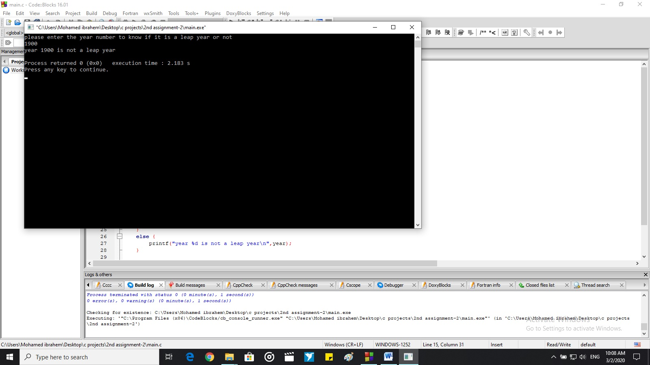

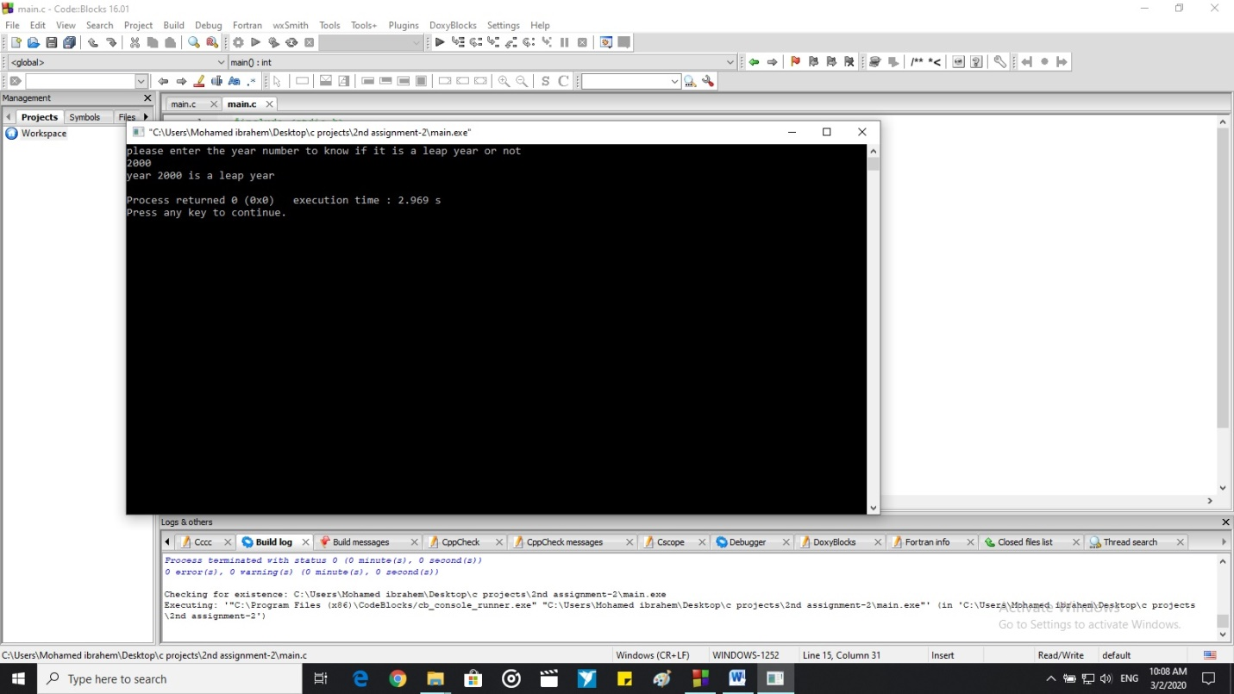

***Code 3***

#include <stdio.h>

#include <stdlib.h>

int main()

{

int y;

char x ;

printf("please enter one character\n");

scanf("%c",&x);

y=(int)x;

if (y>64 && y<91){

printf("this character is uppercase\n");

}

else if (y>96 && y<123){

printf("this character is lowercase\n");

}

else {

printf(" wrong entry, it is not a character \n");

}

return 0;

}

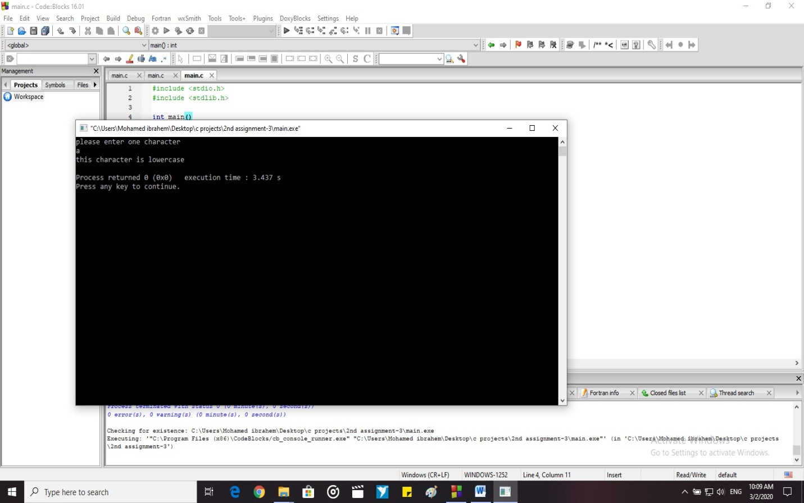

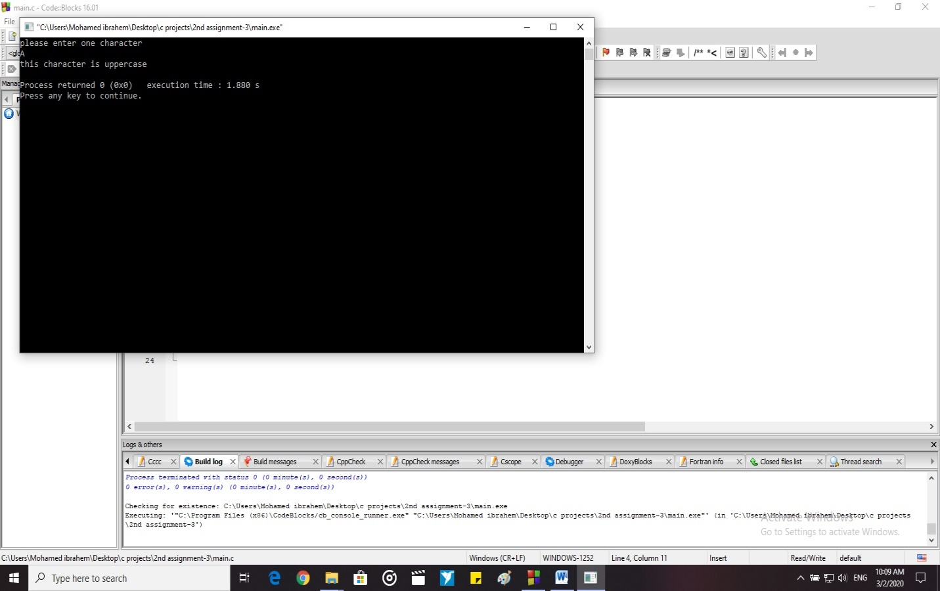

***Code 4:-***

#include <stdio.h>

#include <stdlib.h>

int main()

{

int x ,z ,g,h,j,k,l;

printf("enter a decimal number less or equal 31 \n");

scanf("%d",&x);

if (x<=31){

g=x%2;

z=x/2;

x=z;

h=x%2;

z=x/2;

x=z;

j=x%2;

z=x/2;

x=z;

k=x%2;

z=x/2;

x=z;

l=x%2;

printf("the binary is %d%d%d%d%d\n",l,k,j,h,g);

}

else {

printf(" you entered number more than the maximum which is 31\n");

}

return 0;

}

